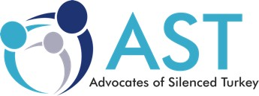

FOR IMMEDIATE RELEASE

Re: Postponement of ***Freedom Forum 2020: Grave Human Rights Violations in Turkey***

We regret to inform you that we are postponing ***Freedom Forum 2020: Grave Human Rights Violations in Turkey*** in Washington, DC on March 24-25.

Given the coronavirus' rapid spread around the globe, we have been closely monitoring news reports and communicating with health departments and local government outlets. Unfortunately, numerous cities and states have declared states of emergency and the health of our participants is our utmost priority. Following suit with other organizations who have postponed their events scheduled for the near future, including many that would have taken place at the National Press Club, we have decided to postpone the ***Freedom Forum 2020: Grave Human Rights Violations in Turkey***.

A new date for the Freedom Forum will be determined and communicated to you in a timely fashion when local and international monitors declare that the threat of coronavirus has been contained.

We are very sorry to have to postpone this event as it will be a great gathering, but we hope you can understand the circumstances.

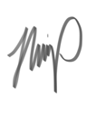

Hafza Y. GIRDAP

Spokesperson

[directorhg@silencedturkey.org](mailto:directorhg@silencedturkey.org)